Greyson & Silas Take on Their Winter Sports

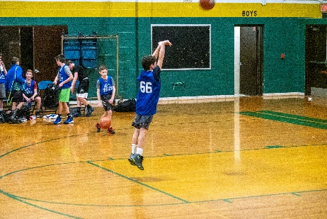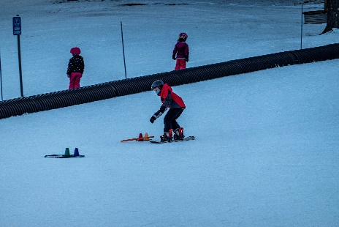The last wekend in January, we motored over to Massachusetts to enjoy watching Greyon and Silas as they participated in their winter sports. Both boys participated in skiing and basketball and we thoroughly enjoyed watching both as they let it out.

And for the photos, click [Winter Sports With Grey & Si](https://photos.app.goo.gl/TVKQkCcxnxe7Vxxc7).